
Worksheet 9 - Nov 14, 2025

Intro to Machine Learning
__________________________

Dataset: spotify_mini.csv

🧠 Goal
Today, you’ll explore how computers learn from data!
We’ll use a small Spotify dataset to understand:
- Train your first machine learning model
- Make predictions using real Spotify data
- Visualize the pattern the computer learned

🧩 Step 1: Load & Explore the Data

1️. Download spotify_mini.csv from GitHub (Week 6) and upload it to your Colab sidebar (Files ➜ Upload).
2️. Run this code 👇:

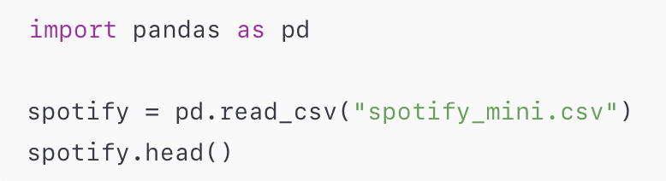
- 📝 Question 1:
What columns do you see in the dataset? List three columns you find interesting.
column 1 | column 2 | column 3

📊 Step 2: Choose a Feature and Label
We’ll try to predict how many streams a song gets based on one feature (for example, skip_rate).
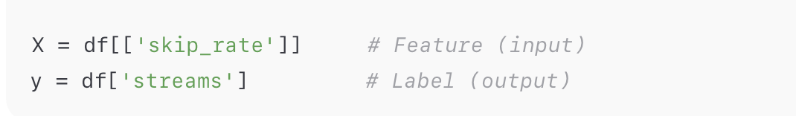
📝 Question 2:
- What is the feature in this example?
- What is the label?
Feature | Label

✂️ Step 3: Split the Data into Training and Testing Sets
We want to see if the computer can learn patterns — so we’ll train it on part of the data and test it on the rest.
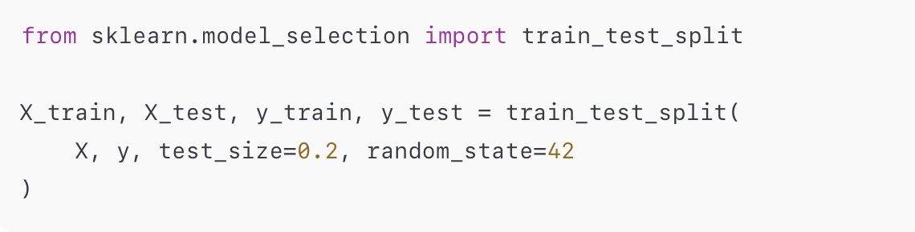
📝 Question 3:
- How much of the data is used for training?
- How much is used for testing?
- Why do we split the data?
Training % | Testing % | Why do we split?

👀 Step 4: Check Your Split
Run this to see how many examples are in each part:
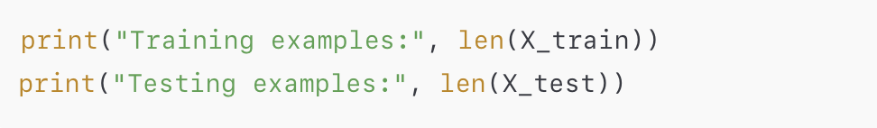
📝 Question 4:
Write down how many rows your training and testing sets have:
Data Type | Number of Rows
Training
Testing

🧠 Step 5: Train the Model
We’ll use a simple model called Linear Regression.
Think of it as: “Draw the smoothest line through the data.”
Run this code:
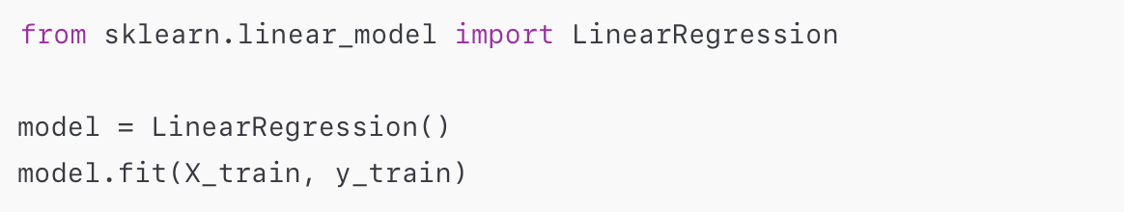

📝 Question 5:
In your own words, what did the computer do when we called model.fit()?
(Example: “It learned the pattern between skip rate and streams.”)

🎯 Step 6: Make Predictions
Now let’s see what the model thinks about the test data.
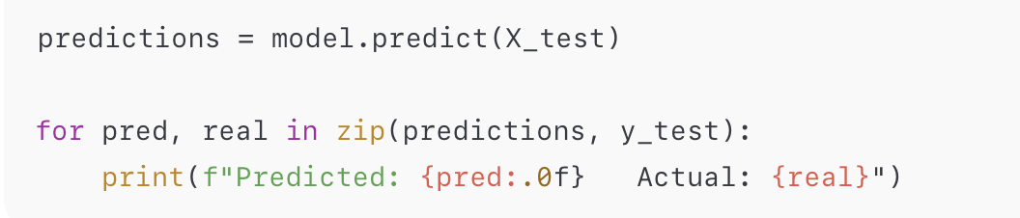

📝 Question 6:
Look at the predicted vs actual values.
Write down one pair:
Predicted Streams | Actual Streams

📈 Step 7: Visualize the Pattern
A graph helps you see what the computer learned.
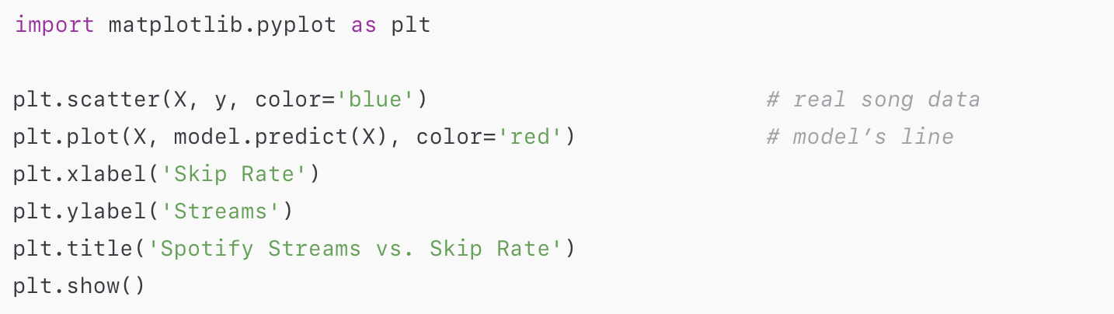

📝 Question 7:
Look at your graph:
- Does the red line match the general direction of the data?
- What does it tell you about skip rate and streams?

💬 Step 8: Reflection
Answer in 1–2 sentences:
- How is this similar to how Spotify guesses whether a song will be popular?

- What do you think would make the model more accurate?
(More data? More features?)

⭐ Bonus Challenge
Try replacing skip_rate with a new feature like minutes_listened:
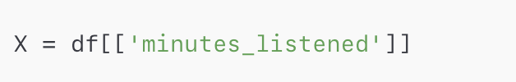
Did your predictions improve?
Why do you think that happened?

